Dedications

Table of Contents

General Introduction 5

Chapter 1 : Project background 6

I. Introduction 6

1 History 6

2 Company Profile: 6

A Definition of I&H POLYMER ENGINEERING: 6

B Technical Specifications : 7

3 Field of Activity: 8

A Official Representative: 8

B Trainer 11

4 Description of I&H POLYMER ENGINEERING: 11

II. Problem Statement 12

1 The problem 12

2 Our Solution 13

III. Gantt chart 13

IV. Conclusion 14

Chapter 2 : Functional Specification 15

I. Introduction 15

II. Solution Description 15

III. Global Use Case Diagram: 17

IV. Conclusion 17

Chapter 3 : Development and Planification 18

I. Introduction 18

II. Methodology and Adopted Formalism 18

1 Methodology 18

A Selecting Agile Scrum Methodology: 18

B The Benefits of Agile Scrum: 18

C How does it work? 19

D Why Scrum? 20

E Main Scrum components: 20

III. Product Backlog 21

IV. Planification of Sprints 23

V. Work Environment 25

1 Physical Environment (Workstation Setup) : 25

2 Technological Environment: 26

A Programming Language and Framework: 26

B Database Management: 27

C Web Development Tools: 28

i. IDE 28

ii. Version Control Systems 29

iii. Booststrap 30

iv. Node Package Managers 30

v. JavaScript libraries and tools: 30

VI. Overview of Application Architecture 32

VII. Conclusion 34

Chapter 4 : First Sprint 34

1 Sprint Backlog: 34

2 Use Case Diagram: 35

3 Sequence Diagram 1: 35

4 Sequence Diagram 2: 36

5 Sprint Review: 36

6 Implementation: 37

Chapter 5 : Second Sprint 40

1 Sprint Backlog 40

2 Use Case Diagram 40

3 Sprint Review 40

4 Implementation 41

Chapter 6 : Third Sprint 45

1 Sprint Backlog 45

2 Use Case Diagram 45

3 Sequence Diagram 46

4 Class Diagram 47

5 Sprint Review 47

6 Implementation 48

Figure 1:I&H POLYMER ENGINEERING Logo 9

Figure 2:TopSolid Logo 10

Figure 3: TopSolid Design Software Solution 10

Figure 4:Simcon software 11

Figure 5:Optimization of plastic injection 11

Figure 6:Thermoforming 12

Figure 7:Blow molding simulation 12

Figure 8: the organizational chart 13

Figure 9:gantt chart 15

Figure 10:Global use case diagram 19

Table 1: Agile Scrum Implementing 21

Figure 11:Sprints planning 26

Figure 12:Pc details 27

Figure 13:system details 28

Figure 14:MVT architecture 36

Figure 15: login sequence diagram 39

Figure 16:registration sequence diagram 40

Figure 17:interface of the login page 41

Figure 18;interface of the profile section interface 43

Figure 19:all users interface 45

Figure 20:edit user interface 46

Figure 21:administration accounts interface 47

Figure 22:add admin account interface 47

Figure 23:screenshot show the Promote button for the superadmin 48

Figure 24:screenshot to show the demote button for the superadmin 48

Figure 25: use case diagram for the third sprint 49

Figure 26:course enrolment sequence diagram 51

Figure 27:third sprint class diagram 51

Figure 28:Manage courses interface 52

Figure 29:upload courses interface 53

Figure 30:edit course interface 54

Figure 31:pop up for add a new topic 55

Figure 32:upload videos popup 55

Figure 33:edit course interface after adding a video 56

Figure 34: All courses interface for the users 56

Figure 35:course details interface 57

Figure 36:course content interface 57

1. General Introduction

# 

# **Project background**

## Introduction

This chapter provides an in-depth look at I&H Polymer Engineering, detailing the company’s history, its operational field, and the specific challenges it aims to overcome. This background sets the stage for understanding the project’s necessity and the solutions it proposes.

### History

The creation of the company I&H POLYMER ENGINEERING was in February 2017. It is a consultancy and expertise firm specializing in computer-aided design (CAD), computer-aided manufacturing (CAM), and digital simulation for the plastics, mechanical, and woodworking industrie

### Company Profile:

#### Definition of I&H POLYMER ENGINEERING:

I&H POLYMER ENGINEERING is a training centre and expertise bureau serving the industry, comprising a team of technical sales representatives, a team of application engineers in CAD/CAM, and simulation in the metal, wood, and plastics sectors. They are official and certified resellers of TopSolid and SIMCON in North Africa.

TopSolid is a global leader in computer-aided design and manufacturing software and enterprise resource planning (CAD/CAM/ERP). They primarily target mechanical engineering, sheet metal work, woodworking, and any industry where machines interact with materials for machining, forming, or shaping parts.

Meanwhile, SIMCON has unique expertise in the field of plastic injection molding.I&H

POLYMER ENGINEERING assure 3 services : Matériaux, process et produit

POLYMER ENGINEERING provides 3 services: Materials, processes, and products:

* Materials: In terms of materials, I&H POLYMER ENGINEERING is a company that, thanks to its qualified staff composed of engineers and designers, assists its clients in selecting materials, machines, and functions, as well as identifying material substitutions.
* Processes: In terms of processes, they assist the client during machining programming using TopSolidCAM and optimize the injection process using Varimos (an optimization system dedicated to plastic parts).
* Products: In terms of products, they handle the design using TopSolid.



Figure 1:I&H POLYMER ENGINEERING Logo

#### Technical Specifications :

|  |  |
| --- | --- |
| Headquarters | Wejdane Center khzema 4051 Sousse |
| Name | I&H POLYMER ENGINEERING |
| Sector of Activity | CAD, CAM, and digital simulation for the plastics, mechanical, and woodworking industries |
| Type of Activity | Engineering and expertise consultancy |
| Email | [direction@ihpolymerengineering.com](mailto:direction@ihpolymerengineering.com) |
| Phone Number | +216 28 015 948 |

### Field of Activity:

#### Official Representative:

I&H POLYMER ENGINEERING is an official representative of two software products: TopSolid and SIMCON. It assists the client in purchasing the software solutions, providing training, and offering service

* TopSolid: TopSolid is a global leader in CAD/CAM/ERP software. It primarily targets mechanical engineering, sheet metal work, woodworking, and any industry where machines interact with materials for machining, forming, or shaping parts.



Figure 2:TopSolid Logo

TopSolid is an integrated CAD/CAM solution including:

* + TopSolid Design: is one of the software solutions of TopSolid. It is a revolutionary CAD software that automatically sorts and classifies tasks and helps design complex assemblies in record time.

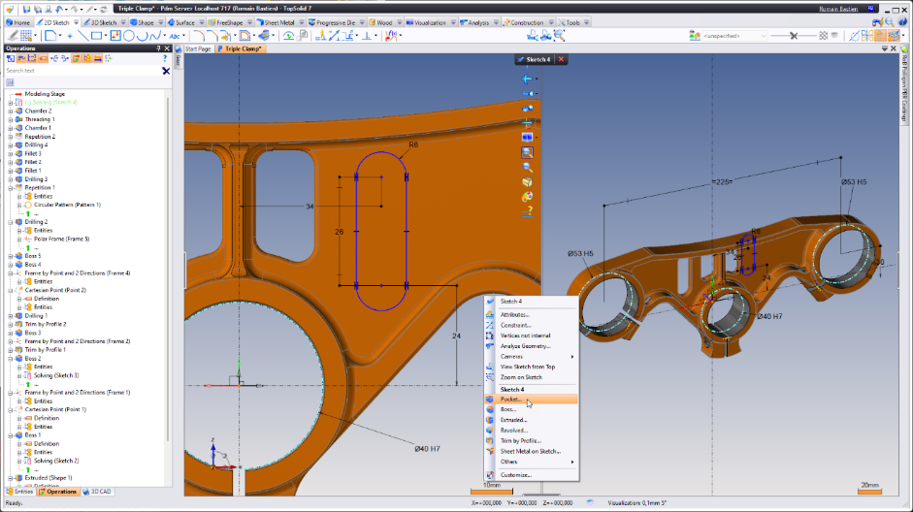

Figure 3: TopSolid Design Software Solution

* + TopSolid MOLD: TopSolid MOLD accelerates the design of core block impressions and helps define all moving parts. This solution optimizes the creation of cooling circuits and quickly produces drafts for mold makers
  + TopSolid CAM: is a comprehensive, simple, intuitive, and scalable CAD/CAM solution for milling, turning, MillTurn, and erosion. It is an ideal tool for production engineering.
  + TopSolid WOOD: is a custom solution tailored to meet client needs, rich in features to boost productivity. It is developed specifically for the woodworking industry with automatic geometry recognition for machining operations.
* SIMCON: is a company specialized in simulation software for polymer processing (injection, thermoforming, blow molding). It offers software solutions such as CADMOULD, T-SIM, and B-SIM.



Figure 4:Simcon software

* + CADMOULD: is a high-tech software product that enables the simulation of plastic injection molding for parts.

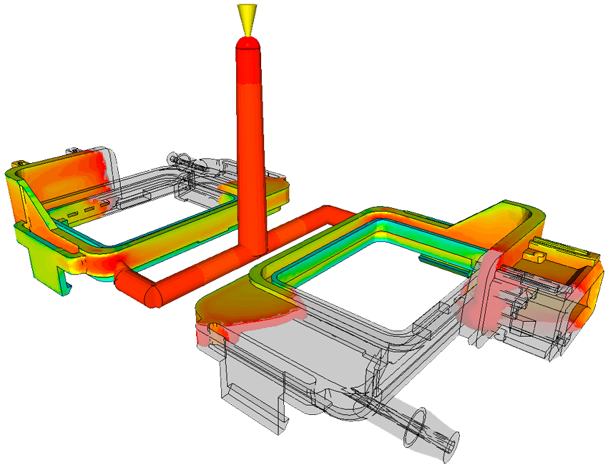

Figure 5:Optimization of plastic injection

* + T-SIM: is a simulation software for thermoforming processes. It relies on a viscoelastic resolution model and can simulate any type of thermoforming.

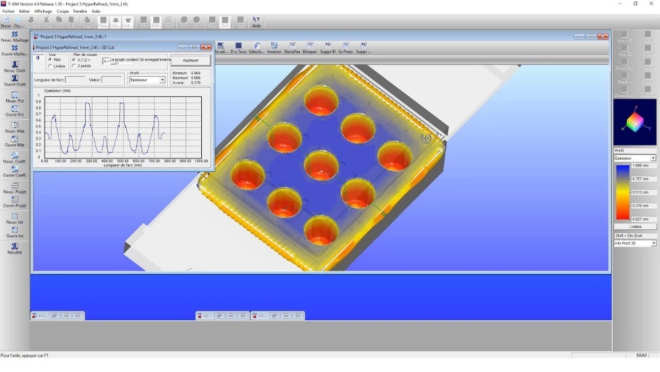

Figure 6:Thermoforming

* + B-SIM: is a software that simulates an injection operation. It offers a functional interface while respecting the chronological order of the different phases to achieve a simulation.

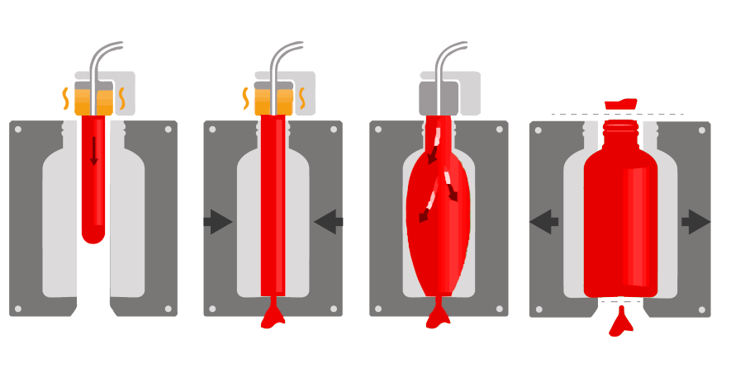

Figure 7:Blow molding simulation

#### Trainer

The company I&H POLYMER ENGINEERING provides three types of training:

* An introductory training that allows testing of the software.
* Certified online or live training in TopSolid and Cadmould.
* Customized training in a specific field of work tailored to its software solutions.

### Description of I&H POLYMER ENGINEERING:

The company I&H POLYMER ENGINEERING consists of a general management which is further divided into two directions: a technical direction and a commercial one. Several departments may take place, such as the plastics, wood, and metal departments

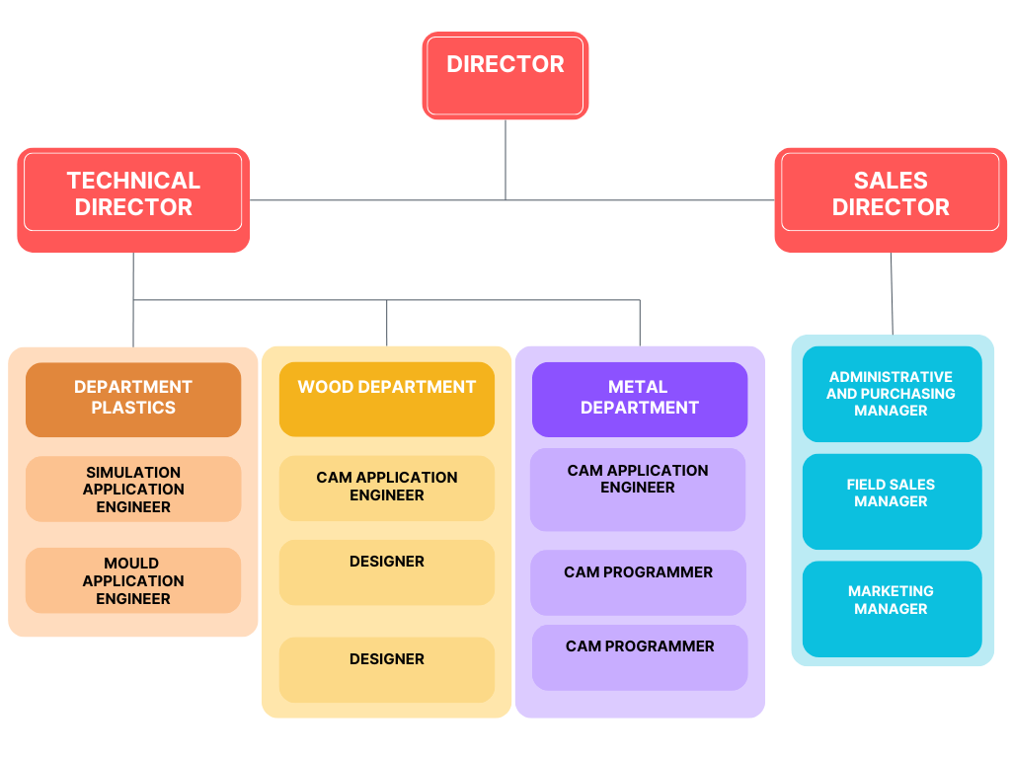

Figure 8: the organizational chart

## Problem Statement

### The problem

Traditional training programs indeed encounter several obstacles that impede their accessibility and effectiveness, prompting our enterprise to seek alternative solutions. A primary challenge is their Limited Availability, as geographical constraints and mobility issues can hinder individuals' ability to attend in-person sessions. This limitation disproportionately affects those in remote areas or with physical disabilities, depriving them of valuable training opportunities.

Additionally, the Lack of Customization in traditional programs is a significant hurdle. Employing a one-size-fits-all approach, these programs often fail to accommodate individual learning styles and specific needs. This standardized approach may result in decreased engagement, lower retention rates, and overall dissatisfaction with the learning experience.

Recognizing these challenges, I&H POLYMER ENGINEERING is motivated to find innovative ways to enhance training accessibility and effectiveness.

### Our Solution

In response to the challenges posed by traditional training programs, I&H POLYMER ENGINEERING proposes a multifaceted solution aimed at enhancing accessibility and effectiveness while addressing the limitations outlined.

Tailored Online Learning Platform: We will develop a state-of-the-art online learning platform that offers flexibility and convenience to participants regardless of their location or physical capabilities.

Virtual Mentorship and Support: To foster a supportive learning environment, we will integrate virtual mentorship programs where participants can connect with experienced professionals in their field. This mentorship will provide guidance, feedback, and real-world insights, enhancing the overall learning experience and facilitating professional growth.

By leveraging technology and innovative pedagogical approaches, I&H POLYMER ENGINEERING is committed to revolutionizing training methods, making them more accessible, customizable, and engaging for all participants. Through our comprehensive solution, we aim to empower individuals to acquire new skills, advance their careers.

## Gantt chart

In our project, I've included a Gantt chart to help visualize the timeline of tasks. This chart displays the various activities I need to complete and the corresponding timeframes for each. For example, I've divided my project into different phases, such as planning, development.

A Gantt chart is a visual representation of a project schedule, displaying the timeline of tasks, activities, and milestones. It consists of a horizontal axis representing time and a vertical axis listing the tasks or activities. Bars are used to represent each task, with their length indicating the duration of the task and their position on the timeline showing when the task is scheduled to start and end. Gantt charts provide a clear overview of project progress, task dependencies, and deadlines

Each phase is represented by a bar on the chart, with its length indicating the duration of that phase. I've also listed specific tasks within each phase, such as research, conception, and technology learning. These tasks are shown as smaller segments within each phase bar.

The Gantt chart allows me to see the sequence of tasks and their interdependencies. For instance, certain tasks need to be completed before others can begin, and the chart helps me identify these relationships easily.

By using the Gantt chart, I can effectively manage my project timeline, track progress, and ensure that I stay on schedule. It's a valuable tool for organizing my work and ensuring that I'm aware of my responsibilities and deadlines

Figure 9:gantt chart

## Conclusion

Concluding this chapter, we have established a clear understanding of I&H Polymer Engineering’s legacy, current market position, and the driving factors behind the project. This foundation is crucial for appreciating the subsequent solutions and methodologies discussed in the report.

# Functional Specification

## Introduction

Chapter 2 delves into the functional requirements and specifications of the solution devised for I&H Polymer Engineering. It outlines the operational goals and the technical framework designed to meet these objectives effectively.

## Solution Description

Our e-training solution streamlines operations with just three actors:

List of Functionality by actor:

User:

* Register and manage account: Users can easily create and maintain their accounts within the platform.
* Log in and Log out: Seamless login and logout functionality ensure secure access to training materials.
* Enroll in courses: Users have the capability to enroll in desired courses to begin their learning journey.
* Access training materials: Once enrolled, users can access a variety of training materials tailored to their chosen courses.

Administrator:

* Manage user accounts: Administrators have the authority to oversee and manage user accounts, including tasks such as account creation, modification, and deactivation.
* Curate and manage training modules: Administrators curate and organize training modules to ensure relevant and effective content delivery.
* Monitor participant progress: Through a comprehensive dashboard, administrators can track participant progress, performance, and engagement metrics to optimize the learning experience.

Super Administrator:

* Manage Administrator accounts: Super Administrators have elevated privileges to oversee and manage administrator accounts, ensuring smooth coordination and administration of the training platform.

During the development phase, our primary focus will be on refining functionalities tailored to the Administrator's role, ensuring efficient account management, content curation, and participant monitoring capabilities.

**Functional Specification:**

Ease-of-use: The platform's interface prioritizes simplicity and intuitiveness, enabling users, administrators, and super administrators to navigate seamlessly and perform tasks efficiently.

Attractiveness: Incorporating visually appealing design elements and an intuitive layout enhances user engagement and satisfaction across all levels of interaction within the platform.

Response time: Efficient processing algorithms minimize response time, facilitating smooth interactions and transitions within the platform, enhancing user satisfaction and engagement.

## Global Use Case Diagram:

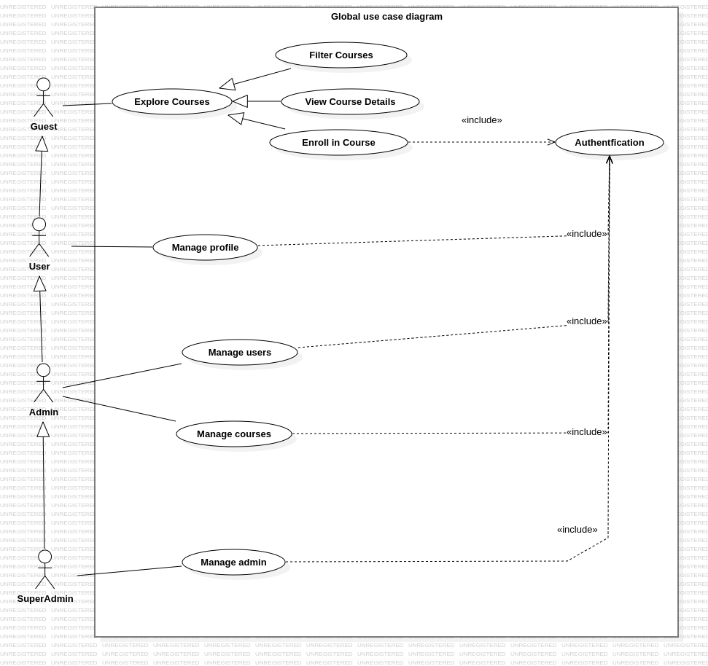

Figure 10:Global use case diagram

## Conclusion

The specifications detailed in this chapter provide a blueprint for the development phases that follow. They ensure that all functional aspects of the solution are aligned with the company’s goals, setting a clear path for implementation.

# Development and Planification

## Introduction

This chapter discusses the development strategy and planning for the project, focusing on the Agile Scrum methodology adopted. It explains the selection process, benefits, and the overall structure of the development cycles.

## Methodology and Adopted Formalism

### Methodology

#### Selecting Agile Scrum Methodology:

When we talk about selecting a methodology, it's like choosing a roadmap for our project. There are many different ways to manage a project, and we have to pick the one that best fits our needs. We chose Agile Scrum because it's like a flexible and adaptable roadmap that helps us navigate through the ups and downs of our project journey.

#### The Benefits of Agile Scrum:

Agile Scrum offers a structured way to manage projects, bringing big advantages for organizations. Let's break it down:

* **Adaptability:** Scrum helps teams stay flexible by breaking projects into smaller parts. This makes it easy to adjust to changes as they happen, like rearranging Lego pieces to build a better structure.
* **Progress and Motivation:** With Scrum, we work on small bits of the project at a time, which keeps things moving quickly. Meeting small goals along the way keeps everyone motivated, like crossing off tasks on a to-do list.
* **Happy Users:** Scrum ensures we listen to users and make changes based on their feedback. This keeps them satisfied with the final product, like tweaking a recipe until it tastes just right.
* **Teamwork:** Everyone in the team shares ideas and works together. It's like collaborating on a fun project where everyone's input matters.

In short, Agile Scrum helps us manage projects better, improving quality and efficiency.

#### How does it work?

Scrum operates by the development team, in this case called Scrum Team, into 3 main parts

* Developers: these are the people in the Scrum Team that are committed to creating any aspect of a usable Increment each Sprint
* Product Owner: he/she is accountable for maximizing the value of the product resulting from the work of the Scrum Team. How this is done may vary widely across organizations, Scrum Teams, and individuals
* Scrum Master: he/she is accountable for establishing Scrum as defined in the Scrum Guide. They do this by helping everyone understand Scrum theory and practice, both within the Scrum Team and the organization.

|  |  |
| --- | --- |
| * Roles | Product Owner |
| Product Owner | Hikmet Houich |
| Development Team | Jamel Miraoui |
| Scrum Master | Rouatbi Adnen |

Table 1: Agile Scrum Implementing

The Scrum Team is responsible for creating and ordering by priority the Product backlog along with the client and the shareholders in the company. Then, the Product Backlog is divided into Design Sprints. Each sprint manage one item in the Backlog. After mapping out the timeline and the deadlines of the design sprints, the team then start to work by the first sprint by dividing the corresponding backlog item into user stories. Followed by the creation of the sprint backlog that contains all the user stories in order of importance. At the end of each sprint. The Team should end up with a miniature version of the product that contains the item of the product backlog previously selected. Also called a Release, this prototype is finally presented to the client for review. If he finds the need for a change then the new functionality or observation is added to the product backlog and a new order is established. If not, then we simply move on to the next sprint. Where in the end we should a product ready for release.

#### Why Scrum?

Scrum is the best suited development method to our project’s nature. This is thanks to the advantages that Scrum have over the other methods such as:

* It can help teams complete project deliverables quickly and efficiently.
* It uses time and resources effectively which is helpful in the case of a small scale company.
* Developments are coded and tested during the sprint review which helps adopting feedback from customers and/or stakeholders.
* Works well for fast-moving development projects.

However, like all frameworks and methods, Scrum has its down sides two. Including:

* The chances of project failure are high if individuals aren’t very committed or cooperative.
* Adopting Scrum in large teams is challenging, and if any of those members leaves in the middle of production then there will be a big impact on the project.
* Also quality is hard to implement until the team goes through an aggressive testing process.

#### Main Scrum components:

* Earlier, you might have read a couple of terms that are of unknown nature. Those were one of the main features that defines Scrum. Some of which are:   
  o Product backlog: the Product Backlog is an emergent, ordered list of what is needed to improve the product. It is the single source of work undertaken by the Scrum Team. o Design Sprint: They are fixed length periods of work that last one month or less to create consistency and ensure short iterations for feedback in order to inspect and adapt both how work is done and what is being worked on o
* Sprint Backlog: the Sprint Backlog is composed of the Sprint Goal (why), the set of Product Backlog items selected for the Sprint (what), as well as an actionable plan for delivering the Increment (how). o
* User Story: A user story or agile/ scrum user story is a tool that's used in agile software development and product management to represent the smallest unit of work in the framework. It provides an informal, natural language description of a feature of the software or product from the end-user perspective. For example: As Max, I want to invite my friends, so we can chat. This would be considered a good user story. o
* Increment: an Increment is a concrete stepping stone toward the end result. Each Increment is additive to all prior Increments and thoroughly verified, ensuring that all Increments work together. In order to provide value, the Increment must be usable. It also called Release in some cases.

## Product Backlog

The Product Backlog is a comprehensive list of all the desired features and functionalities for a product, serving as a dynamic roadmap for the development team. Each item in the backlog, known as a user story, captures a specific requirement from the perspective of the end user or stakeholder. These user stories are detailed with a unique identifier, a clear description of the need. The prioritization of user stories is determined based on several factors including the business value they provide, the frequency of their use, their impact on risk reduction, their ability to clarify uncertain user needs, their contribution to the overall quality of the product, and their dependencies on other stories.

|  |  |  |  |
| --- | --- | --- | --- |
|  | id | As ... | I want to... |
| Sprint 1 | 1 | User | Login |
| 2 | User | register for an account |
| 3 | User | update profile information |
| Sprint 2 | 4 | Admin | edit user details |
| 5 | Admin | delete user accounts |
| 6 | Admin | add a user |
| 7 | Super Admin | add an admin |
| 8 | Super Admin | edit an admin |
| 9 | Super Admin | remove an admin |
| 10 | Super Admin | promote a user to admin |
| 11 | Super Admin | depromote an admin |
| Sprint 3 | 12 | Admin | add a course |
| 13 | Admin | edit a course |
| 14 | Admin | remove a course |
| 15 | Admin | manage the content |
| 16 | Admin | Add a topic in a course |
| 17 | Admin | edit a model in a course |
| 18 | Admin | delete a model in a course |
| 19 | Admin | add an article in a model |
| 20 | Admin | edit an article in a model |
| 21 | Admin | delete an article in a model |
| 22 | Admin | add a video in a model |
| 23 | Admin | edit a video in a model |
| 24 | Admin | delete a video in a model |
| 25 | User | see the list of courses |
| 26 | User | filter the list of courses |
| 27 | User | see the course details |
| 28 | User | enrol in a course |
| 29 | User | see the content of the course |

## Planification of Sprints

In Sprint 1, our focus will be on implementing essential user functionalities, primarily centered around authentication and account management. We'll start by enabling users to register and log in to their accounts, ensuring seamless access to the platform. Additionally, users will be able to update their profile information, ensuring accuracy and relevance. To enhance the user experience, we'll provide features for browsing and filtering available courses, allowing users to explore and find courses tailored to their interests and skill levels.

Sprint 2 shifts our attention towards administrative capabilities, empowering platform administrators and super administrators with tools for user and account management. Admins will gain the ability to edit and delete user details, as well as add and remove users from the platform. Super admins will have advanced privileges, including the management of admin roles and permissions. These enhancements will ensure robust control over platform access and administrative functions.

In Sprint 3, the focus expands to course management functionalities, enabling admins to enrich the platform's course catalog and enhance the learning experience. Admins will be able to add, edit, and remove courses, ensuring the catalog remains up-to-date and relevant. Furthermore, they'll have tools for managing course content, including models, articles, and videos, providing learners with diverse and engaging learning materials. For users, these improvements will facilitate easier course discovery, enrollment, and access to course content, fostering a seamless and enriching learning journey.

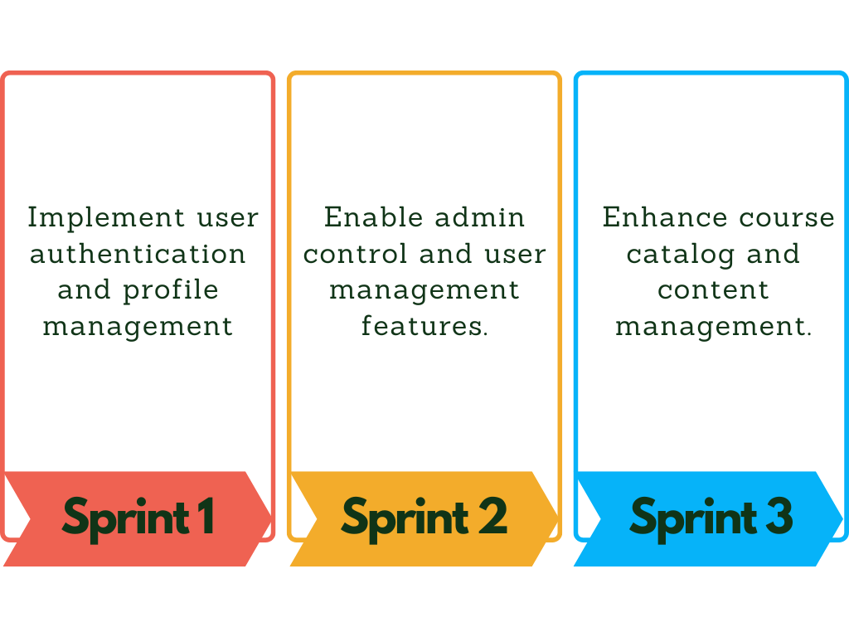

Figure 11:Sprints planning

## Work Environment

### Physical Environment (Workstation Setup) :

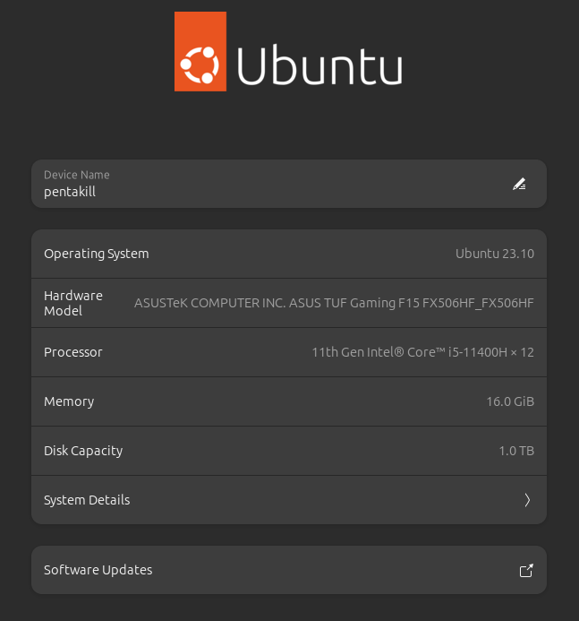

Figure 12:Pc details

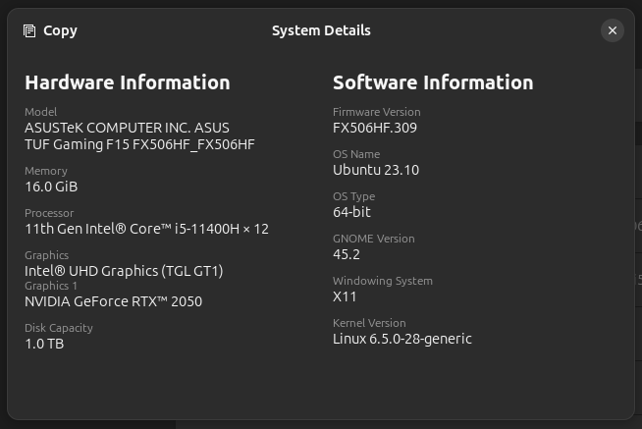

Figure 13:system details

### Technological Environment:

#### Programming Language and Framework:

, a free and open-source framework built using Python, a popular and beginner-friendly programming language. It streamlines the web development process by providing a robust structure and a collection of pre-built features. This allows developers to focus on the core functionalities of their web application rather than re-inventing the wheel for common tasks like user authentication, database interactions, and URL routing.

Here's what makes Django stand out:

**Rapid Development:** Django enforces a clean and organized Model-Template-View (MTV) architectural pattern. This structure promotes code reusability and simplifies the development cycle. Developers can leverage pre-built components and functionalities, saving them time and effort.

**Security:** Django prioritizes security by incorporating features that help mitigate common web development vulnerabilities like SQL injection and cross-site scripting (XSS) attacks. This built-in security focus empowers developers to build secure web applications without needing to be experts in web security.

**Scalability:** Django is designed to handle small to large-scale web applications. Its architecture allows for easy scaling by distributing tasks across multiple servers. This makes it suitable for applications with growing user bases and complex functionalities.

**Versatility:** Django is a versatile framework that can be used to build a wide range of web applications, from simple content management systems (CMS) to complex social networking platforms and e-commerce applications.

#### Database Management:

 In the realm of database management, MySQL stands out as a powerful and versatile open-source relational database management system (RDBMS). Its speed, reliability, and scalability have made it a cornerstone of the LAMP (Linux, Apache, MySQL, PHP/Python/Perl) web application stack. MySQL's adherence to the ANSI SQL standard ensures compatibility with a wide range of programming languages and tools, fostering its adoption in a diverse range of projects. What truly sets MySQL apart is its combination of strengths:

* **Open-Source Advantage:** Freely available under the GNU General Public License, MySQL eliminates licensing costs, making it a budget-friendly option for many developers.
* **Platform Agnostic:** Its ability to run seamlessly across various operating systems, including Linux, Windows, and macOS, provides flexibility in development environments.
* **Security Focus:** MySQL offers robust security mechanisms, such as user authentication, access control, and encryption, to safeguard your valuable data.
* **Community Strength:** Backed by a large and active developer community, MySQL benefits from extensive documentation, tutorials, and readily available support resources.
* **Performance and Growth:** Designed to efficiently handle large datasets, MySQL also scales effectively to accommodate the growing demands of your application.

#### Web Development Tools:

##### IDE

 In our project, choosing the right development tool was very important for efficient and effective software development. We used PyCharm, an integrated development environment (IDE) developed by JetBrains, which is especially good for Python development.

PyCharm

PyCharm is a powerful and versatile IDE designed to make coding in Python easier and more efficient. It has many features that help developers write better code faster.

**Smart Code Completion:** PyCharm provides smart suggestions as you type, helping you write code faster and with fewer mistakes. This feature predicts what you are going to type next, making coding more efficient.

**Debugging and Testing:** The IDE includes strong debugging tools that help you find and fix problems in your code. It also supports various testing frameworks, which help you ensure your code works correctly.

**Refactoring Tools**: PyCharm offers tools to improve and clean up your code. These tools help you make your code better organized and easier to maintain without introducing errors.

In our project, PyCharm was very useful for backend development. Its smart coding help and debugging tools significantly improved our productivity and code quality. By using PyCharm, we were able to write better code more quickly and find and fix problems more easily.

##### Version Control Systems

Version control is a system that tracks changes to files over time. This allows you to revert to previous versions if necessary, collaborate with others on the same project, and maintain a clean codebase

**GitHub: A Leading Version Control Platform**

GitHub is a popular platform for hosting code repositories, managing projects, and collaborating with others. It provides a web interface with features like code hosting, issue tracking, pull requests, and more. Millions of developers around the world use GitHub to collaborate on projects of all sizes.

**GitHub Desktop: A User-Friendly Graphical Interface**

GitHub Desktop is a graphical application that simplifies interaction with GitHub. It provides a user-friendly interface for creating, cloning, and managing repositories. GitHub Desktop also allows you to visually see code changes, making it easier to understand what has been modified in your project. Additionally, it offers easy-to-use workflows for making commits, pushing changes to your remote repository, and pulling updates from others. If you're not comfortable using command-line Git commands, GitHub Desktop is a great alternative.

**Benefits of Using GitHub and GitHub Desktop for Your Project**

There are several benefits to using GitHub and GitHub Desktop for your final project. First, version control allows you to securely track changes to your code. This means you can revert to previous versions if something goes wrong or if you need to collaborate with others on different parts of the project. Second, GitHub makes it easy to collaborate with teammates. You can share your code with others, track changes, and review each other's work before merging it into the main codebase. Third, GitHub Desktop's visual interface makes it easier to understand what changes have been made to your code, which can help to facilitate code review and maintain a clean codebase. Finally, using version control keeps a history of your project development, which can be helpful for future reference

##### Booststrap

is a robust and widely-used front-end framework for building responsive and visually appealing websites and web applications. It provides a comprehensive set of pre-designed HTML, CSS, and JavaScript components, such as buttons, forms, navigation bars, and grids, which can be easily integrated into web projects to accelerate development and ensure consistency across different devices and screen sizes. Bootstrap CSS employs a grid-based layout system and a mobile-first approach, making it simple to create layouts that adapt seamlessly to various viewport sizes.

##### Node Package Managers

Node Package Manager (npm) is a widely-used package manager for JavaScript, primarily used for managing dependencies in Node.js projects. With npm, developers can easily install, share, and manage packages of code. In our project, npm played a crucial role in integrating various libraries and dependencies seamlessly. By utilizing npm, we were able to efficiently install necessary libraries and frameworks required for our project's frontend development. Once installed, these libraries were conveniently integrated into our Django project by copying them into the static folder. This allowed us to leverage the power of npm's package ecosystem while seamlessly integrating the functionality into our Django application

##### JavaScript libraries and tools:

**Slick Carousel:** is a feature-rich jQuery plugin for creating responsive, customizable, and touch-enabled carousels or sliders. It offers a wide range of configuration options and supports various types of content, including images, videos, and HTML elements.

**Sal.js**: is a lightweight and performance-focused JavaScript library for animating scroll behavior. It enables developers to easily add smooth and customizable scroll animations to elements on a web page, enhancing user experience and engagement.

**Feather Icons:** is a collection of beautifully designed open-source icons that are lightweight and easy to use. These icons are available in SVG format, making them scalable and customizable for use in web projects.

**Font Awesome:** is a popular icon font and toolkit that provides a vast library of scalable vector icons. It offers a wide range of icons for various purposes and allows developers to easily incorporate icons into their web applications using CSS classes or JavaScript.

Euclid Circular A Font: is a modern and geometric sans-serif typeface designed for digital interfaces. It features a clean and elegant design, making it suitable for use in web and mobile applications, as well as for print media.

**Swiper.js:** is a powerful and flexible JavaScript library for creating touch-enabled sliders, carousels, and galleries. It offers a wide range of customization options, including navigation controls, pagination, and autoplay functionality, making it ideal for building interactive and mobile-friendly interfaces.

**Magnify.js:** Magnify.js is a lightweight JavaScript library for adding image magnification functionality to web pages. It allows users to zoom in on images with a smooth and responsive zoom effect, enhancing the viewing experience of high-resolution images.

**Odometer.js:** is a JavaScript library for creating smooth and animated number counters on web pages. It enables developers to easily animate numeric values, such as counts or statistics, with customizable transition effects.

**animate.css**: is a popular CSS animation library that provides a collection of pre-built animations for adding motion and visual effects to web elements. It offers a simple way to incorporate animations into web projects without the need for complex JavaScript coding.

**Bootstrap Select:**is an extension for the Bootstrap framework that enhances the functionality of HTML select elements. It provides features such as live search, multiple selection, and custom styling, allowing developers to create more user-friendly and visually appealing select dropdowns.

**jQuery UI:** is a curated set of user interface interactions, effects, widgets, and themes built on top of the jQuery JavaScript library. It offers a wide range of UI components, including drag-and-drop functionality, accordion menus, date pickers, and dialog boxes, making it easier for developers to create rich and interactive web interfaces.

**Magnific Popup:** is a responsive and customizable lightbox plugin for displaying images, videos, and other content in a modal window. It provides support for various types of media and offers options for controlling the appearance and behavior of the popup.

**Plyr.js**: is a simple and lightweight JavaScript library for creating customizable HTML5 video and audio players. It provides a consistent and accessible player interface across different browsers and devices, with support for features such as full-screen mode, captions, and custom controls.

**Noty**: is a jQuery plugin for creating customizable notification messages on web pages. It allows developers to display informative or interactive notifications to users, with support for various types of notifications, including alerts, success messages, warnings, and error messages.

## Overview of Application Architecture

Many web application frameworks, including Django, employ the MVT architecture to structure and organize code. MVT stands for Model-View-Template, which represents three distinct layers that work together to deliver a cohesive user experience.

**Model:** The Model layer serves as the foundation of your application. It defines the data structures that your application will utilize. Imagine it as a blueprint for your database, specifying the type of data each table will hold and the relationships between them. Here, you'll establish entities (like "Product" or "User") and their corresponding attributes (e.g., "Product Name", "User Email"). The Model layer interacts with the database to perform operations like data retrieval, creation, and modification.

**View:** The View layer acts as the intermediary between the Model and the Template. It receives user requests, typically triggered by a user interacting with a web page. The View interacts with the Model to fetch or manipulate data based on the request. Business logic specific to your application often resides in the View layer. For instance, a View might process a user login request by checking credentials against the Model data and generating an appropriate response.

**Template:** The Template layer is responsible for presenting data to the user in a visually appealing way. Templates are typically written in HTML, but can incorporate other languages like CSS and Javascript for styling and interactivity. The View layer provides data to the Template, which then populates the HTML structure with dynamic content. This separation allows for clean and maintainable code, as the presentation layer (Template) remains independent of the data layer (Model).

**Benefits of MVT:**

**Separation of Concerns:** Each layer focuses on a specific responsibility, promoting modularity and reusability.

**Maintainability:** Changes to one layer (e.g., the Model) have minimal impact on the others, making updates easier.

**Testability:** Each layer can be tested independently, simplifying the development process.

By leveraging the MVT architecture, developers can build complex web applications with a clear structure and promote long-term maintainability.

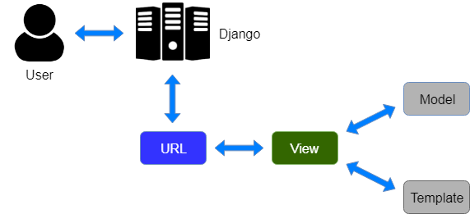

Figure 14:MVT architecture

## Conclusion

With the Agile Scrum framework in place, this chapter concludes by emphasizing the preparedness and strategic outlook for the development phases. It underscores the adaptability and efficiency expected from this approach, paving the way for detailed development tasks in the upcoming sprints

# First Sprint

### Sprint Backlog:

|  |  |  |  |
| --- | --- | --- | --- |
| id | As ... | I want to... | So that… |
| 1 | User | login | I can access the platform and personal account features |
| 2 | User | register for an account | I can create a personalized account for accessing courses and features |
| 3 | User | update profile information | I can maintain accurate and up-to-date personal details. |

### Use Case Diagram:

### Sequence Diagram 1:

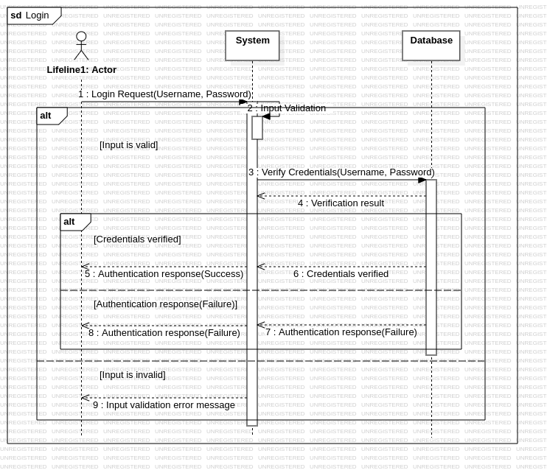

Figure 15: login sequence diagram

### Sequence Diagram 2:

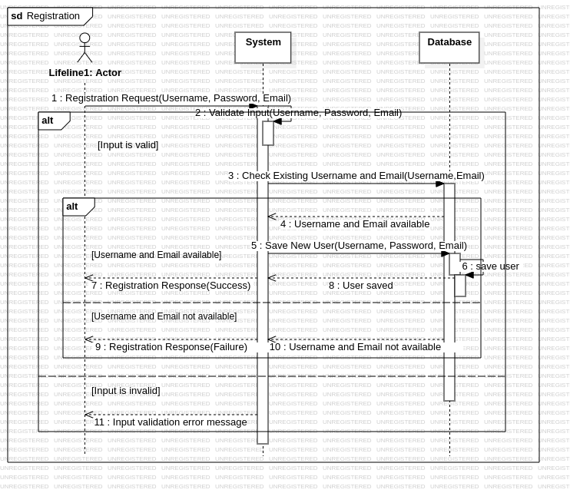

Figure 16:registration sequence diagram

### Sprint Review:

During Sprint 1, our primary focus was on establishing the foundational user management features necessary for a functional e-learning platform. We successfully implemented user registration and login functionalities, allowing users to create personalized accounts and securely access the platform. Additionally, we enabled users to update their profile information, ensuring they can maintain accurate and current personal details. Another significant achievement was developing the course catalog browsing feature, which allows users to view the list of available courses. We also introduced filtering options, enabling users to narrow down courses based on categories and difficulty levels, thereby enhancing the user experience by making it easier to find courses that match their interests and skill levels. Overall, this sprint laid a solid groundwork for user engagement and course exploration.

### Implementation:

As a visitor, you have the freedom to explore the website and access detailed information about the available courses. However, when you're ready to make a purchase, authentication is required. You need to be logged in to proceed with your purchase. In such a case, you will be redirected to the login page where you can input your credentials to authenticate yourself.

Users log in to the app by entering their email and password on the login screen. After providing their credentials, they click "Sign in." If the login is successful, users are directed to the index of the user interface. If the user is an admin, they are directed to the admin panel. However, if the credentials are incorrect, an error message is displayed.

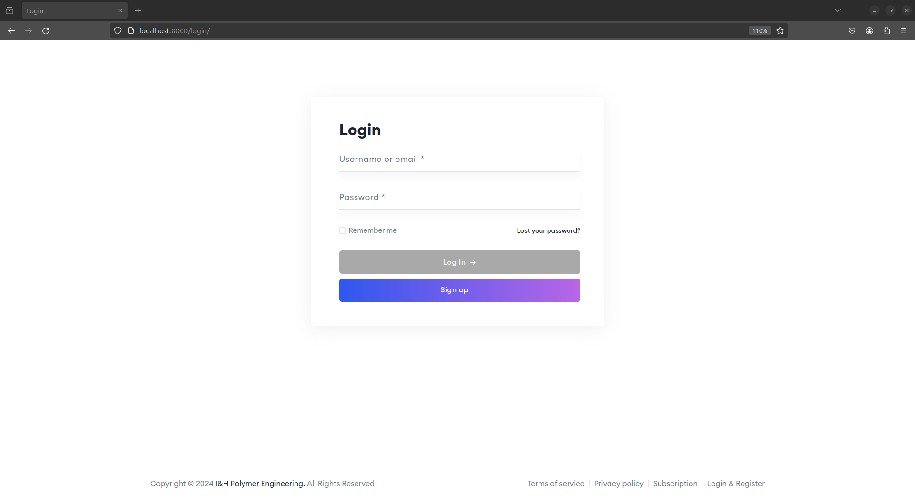

Figure 17:interface of the login page

If users don't have an account, they can click on the "Register" button. This directs them to the registration page where they can provide their personal details such as full name, email, and password. Once they complete the registration form and submit it, they are then redirected back to the login page where they can use their newly created credentials to log in.

During registration, if there is an issue such as an already used email or username, or if the password is considered weak, users will receive a notification message indicating the specific error. This message will prompt them to correct the issue and resubmit their registration details.



After logging in, users have the option to update their account information, including personal details such as name, email, and any other relevant information. Additionally, they can update their profile photo to personalize their account further. This functionality allows users to keep their account information up-to-date and customize their profile to their preferences.

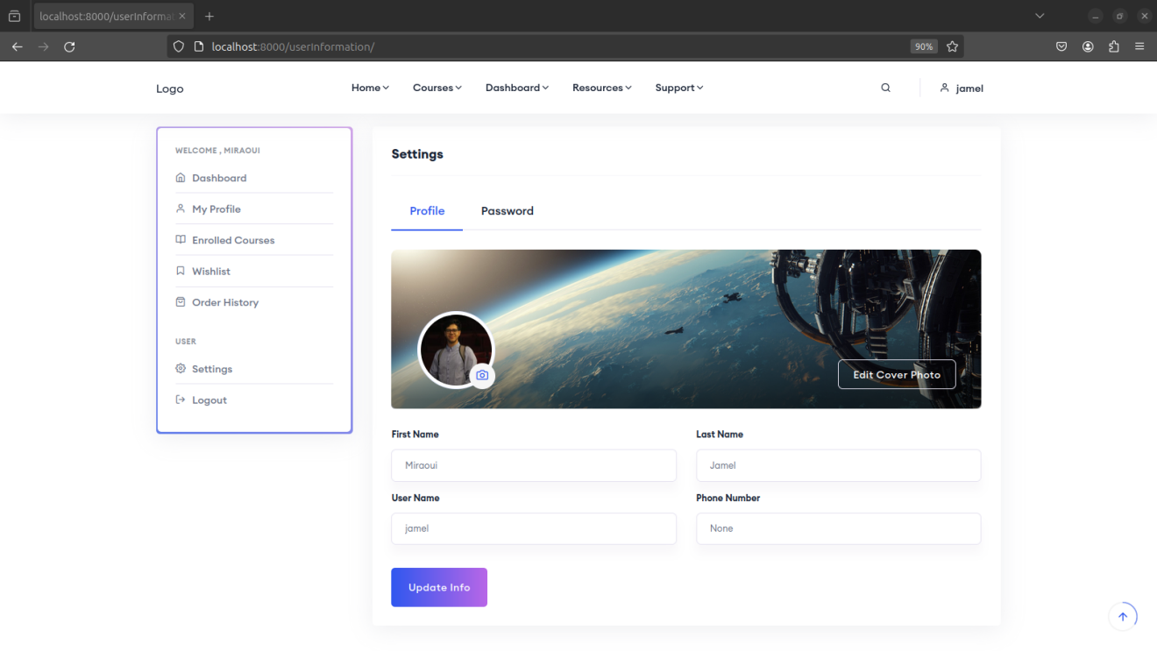

Figure 18;interface of the profile section interface

### Conclusion

# Second Sprint

### Sprint Backlog

|  |  |  |  |
| --- | --- | --- | --- |
| id | As ... | I want to... | So that… |
| 1 | Admin | edit user details | I can ensure accurate user information and account management |
| 2 | Admin | delete user accounts | I can manage platform access and user data |
| 3 | Admin | add a user | I can grant access to new users and expand platform membership. |
|  | Super Admin | add an admin | I can assign administrative privileges and manage platform administration. |
|  | Super Admin | edit an admin | I can update administrative permissions and roles. |
|  | Super Admin | remove an admin | I can manage administrative roles and access control. |
|  | Super Admin | promote a user to admin | I can grant additional administrative responsibilities to selected users. |
|  | Super Admin | depromote an admin | I can adjust administrative roles and permissions as needed. |

### Use Case Diagram

### Sprint Review

Sprint 2 was dedicated to enhancing the administrative capabilities of the platform, focusing on user and admin management. We enabled admins to edit user details, ensuring the accuracy and relevance of user information. Admins were also given the ability to delete user accounts, providing essential tools for managing platform access and maintaining a clean user database. Additionally, the functionality to add new users was introduced, allowing admins to expand the platform's membership. For Super Admins, we implemented features to manage admin roles more effectively. Super Admins can now add, edit, and remove admins, as well as promote users to admin roles or depromote admins back to regular user status. These improvements are critical for maintaining robust administrative oversight and ensuring that the platform's user and admin management processes are efficient and secure.

### Implementation

As an admin, when you login, you will be redirected to the admin panel. Within the admin panel, you have the capability to manage the users.

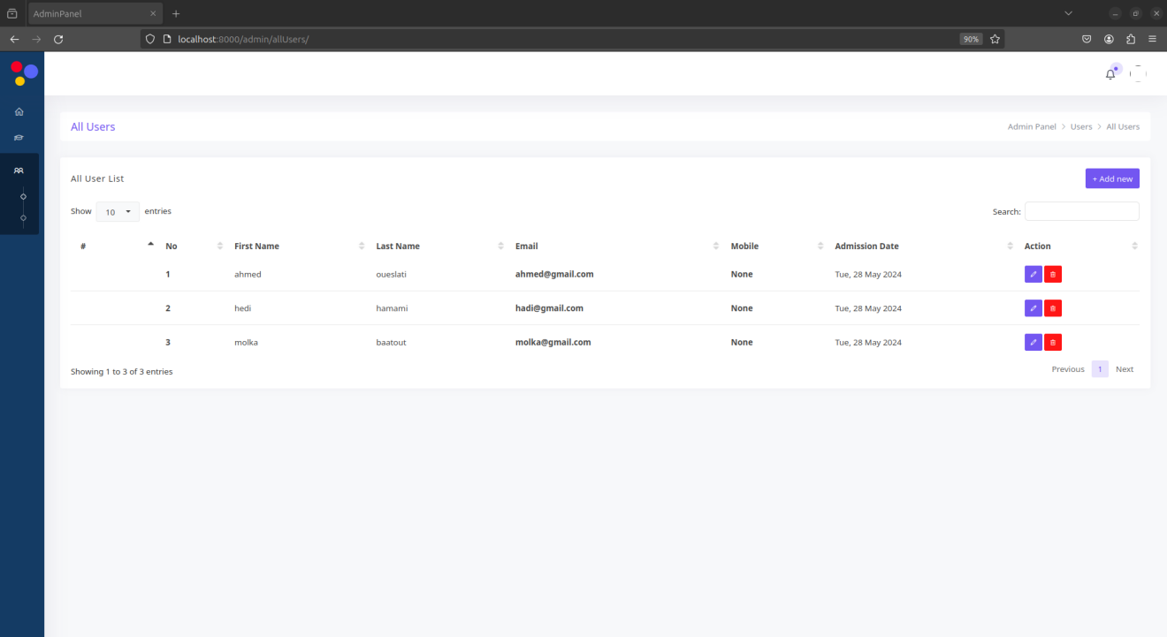

Figure 19:all users interface

This includes the ability to edit user profiles, allowing you to make necessary adjustments to user account details such as updating personal information or modifying account settings.

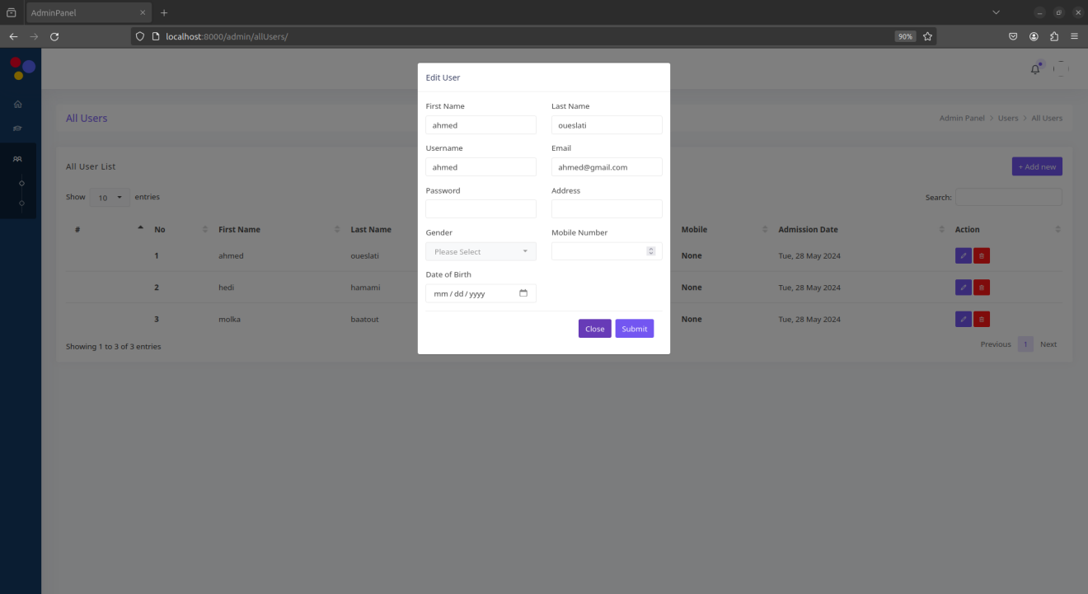

Figure 20:edit user interface

As an admin, you also have the authority to delete user accounts when necessary. This action allows you to remove user profiles from the system, ensuring efficient management of the user base.

As a superadmin, you possess the authority to oversee and manage both user and administrator accounts. Through the staff interface, you have full visibility of all administrators within the system. This enables you to delete or edit administrator accounts as necessary.

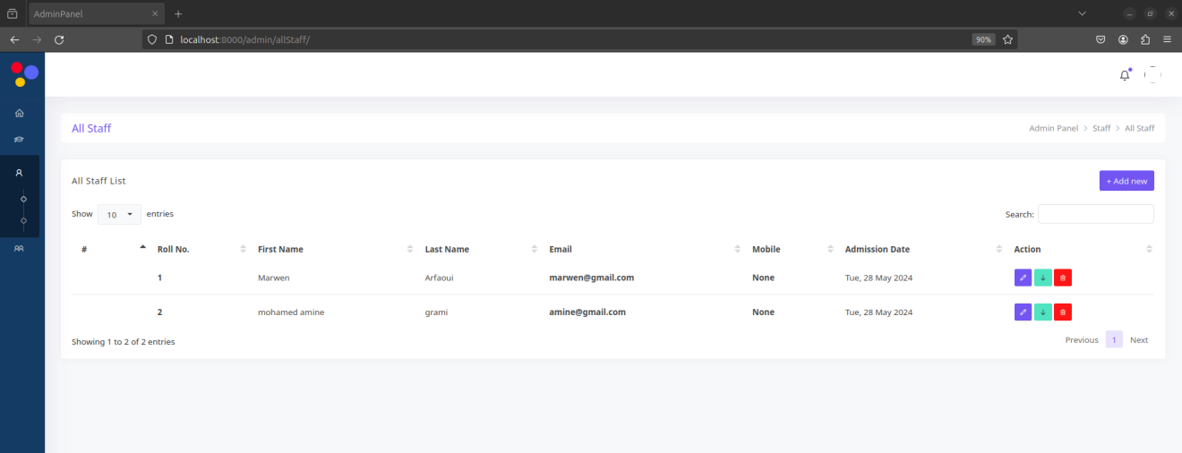

Figure 21:administration accounts interface

Moreover, you have the capability to add new administrators by utilizing the "Add new" button. Clicking on this button redirects you to the add interface where you can create a new administrator account.

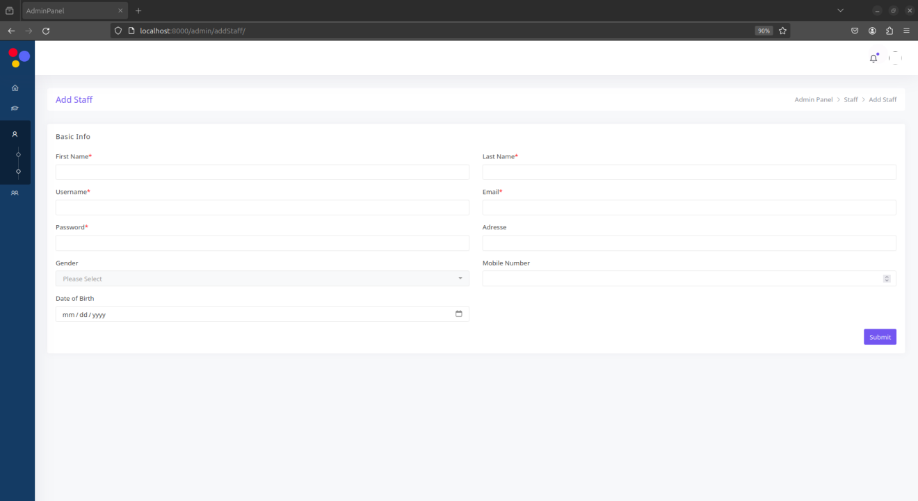

Figure 22:add admin account interface

As a superadmin, you can upgrade a user to an admin and downgrade an existing admin to a regular user.

You can also promote a user to admin by heading to the user management section in the staff interface. Select the user you want to upgrade and click the "Promote" button to grant them admin privilege

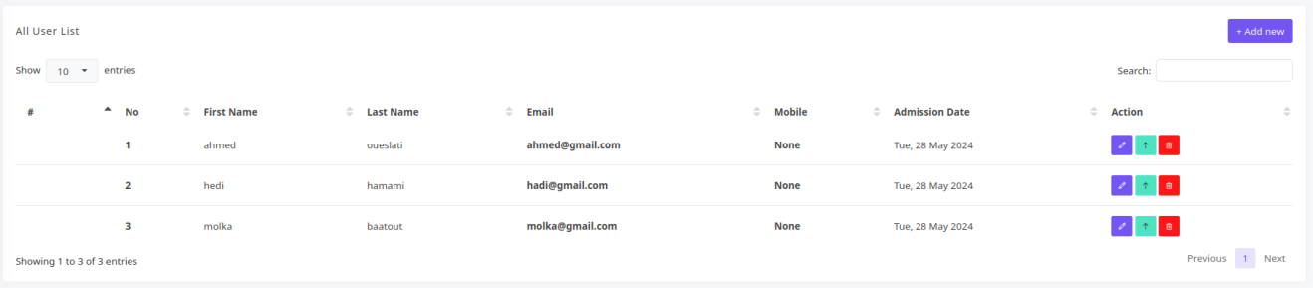

Figure 23:screenshot show the Promote button for the superadmin

Conversely, to demote an admin to a regular user, navigate to the user management section and select the admin. Then, click the "Demote" button to remove their admin rights, just like you clicked the "Promote" button to grant them.

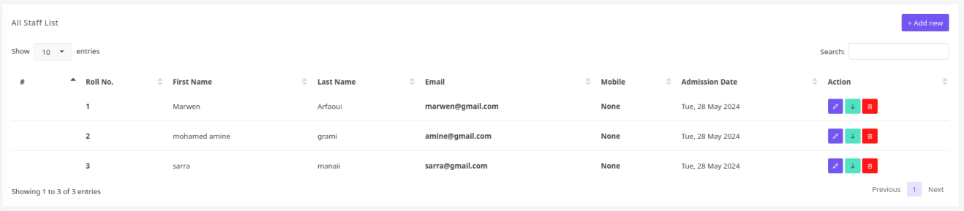

Figure 24:screenshot to show the demote button for the superadmin

### Conclusion

# Third Sprint

### Sprint Backlog

|  |  |  |  |
| --- | --- | --- | --- |
| id | As ... | I want to... | So that… |
| 1 | Admin | add a course | I can expand the course catalog and offer new learning opportunities. |
| 2 | Admin | edit a course | I can update course details and content as needed. |
| 3 | Admin | remove a course | I can manage the course catalog and remove outdated or irrelevant courses. |
| 4 | Admin | manage the content of the courses | I can ensure course materials are up-to-date and relevant for learners. |
| 5 | Admin | add a model | I can enhance course content with additional learning resources or modules. |
| 6 | Admin | edit a model | I can update and refine course materials for improved learning experiences. |
| 7 | Admin | delete a model | I can remove outdated or unnecessary course content. |
| 8 | Admin | add an article in a model | I can supplement course materials with additional reading materials or resources. |
| 9 | Admin | edit an article in a model | I can update and improve supplementary materials for courses. |
| 10 | Admin | delete an article in a model | I can remove outdated or irrelevant supplementary materials. |
| 11 | Admin | add a video in a model | I can enhance course materials with multimedia content for better engagement. |
| 12 | Admin | edit a video in a model | I can update and improve multimedia content for courses. |
| 13 | Admin | delete a video in a model | I can remove outdated or unnecessary multimedia content from courses. |
| 14 | User | see the list of courses | I can explore available learning opportunities. |
| 15 | User | filter the list of courses | I can find courses that match my interests or needs. |
| 16 | User | see the course details | I can understand what the course offers before enrolling. |
| 17 | User | enroll in a course | I can participate in the learning activities and access the course materials. |
| 18 | User | see the content of the course | I can access and utilize the learning materials provided. |

### Use Case Diagram

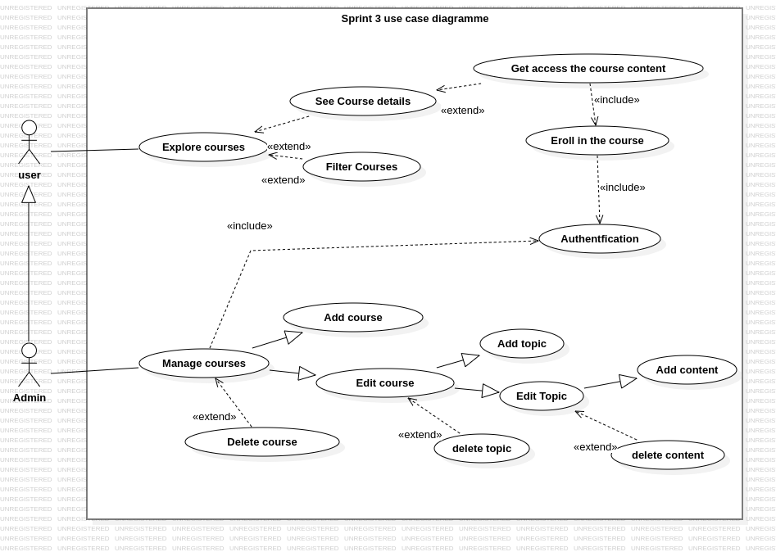

Figure 25: use case diagram for the third sprint

### Sequence Diagram

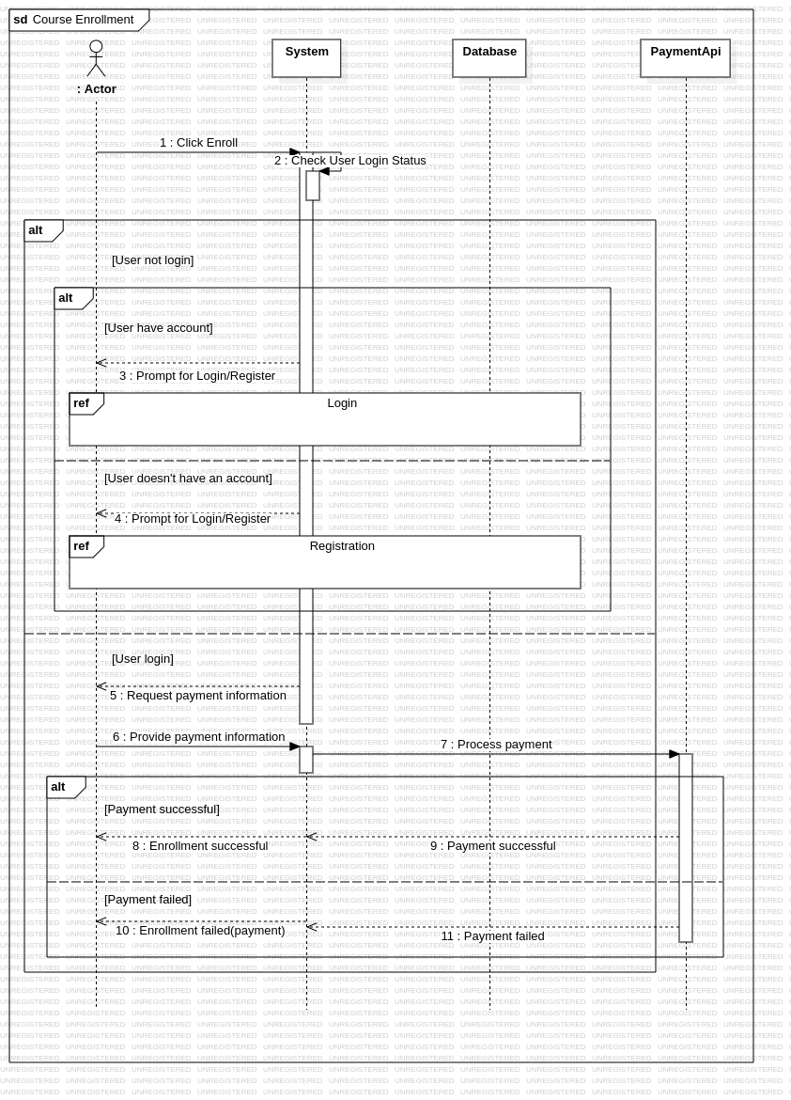

Figure 26:course enrolment sequence diagram

### Class Diagram

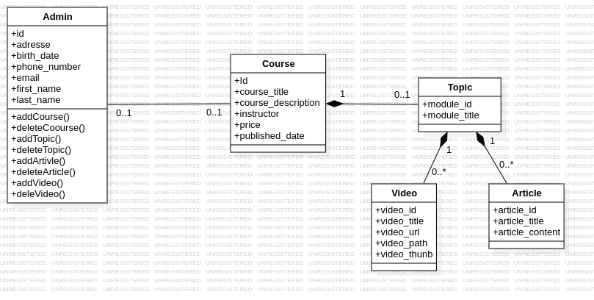

Figure 27:third sprint class diagram

### Sprint Review

In Sprint 3, our efforts were concentrated on expanding and managing the courses, along with providing comprehensive content management features for admins. We developed functionalities for admins to add, edit, and remove courses, which are essential for keeping the coursesdynamic and up-to-date with relevant learning opportunities. Additionally, admins can now manage the content within each course by adding, editing, or deleting models, articles, and videos. This capability ensures that course materials remain current and engaging, enhancing the overall learning experience for users. For users, we implemented features allowing them to view the list of courses, apply filters to find specific courses, view course details, enroll in courses, and access course content once enrolled. These user-centric features complement the admin tools by ensuring that users can easily discover, join, and benefit from the courses available on the platform. Overall, Sprint 3 significantly improved both the administrative and user experiences, reinforcing the platform's ability to offer high-quality, up-to-date educational content.

### Implementation

The course management page within the admin panel serves as the central hub for overseeing all courses available on the platform. Administrators access this page to view, edit, and manage the entire catalog of courses. Here, they can see a comprehensive list of all courses, along with their respective details such as titles, descriptions…

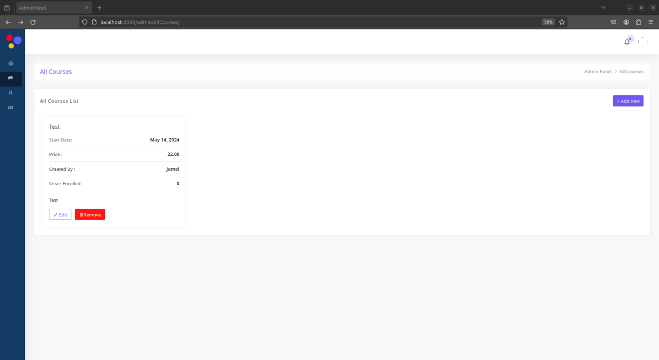

Figure 28:Manage courses interface

To add a new course, administrators simply click on the 'Add' button, which redirects them to the create course page. From there, they provide essential information about the course such as the title, description and category, by filling out a form. Additionally, administrators have the option to upload a cover image that visually represents the course

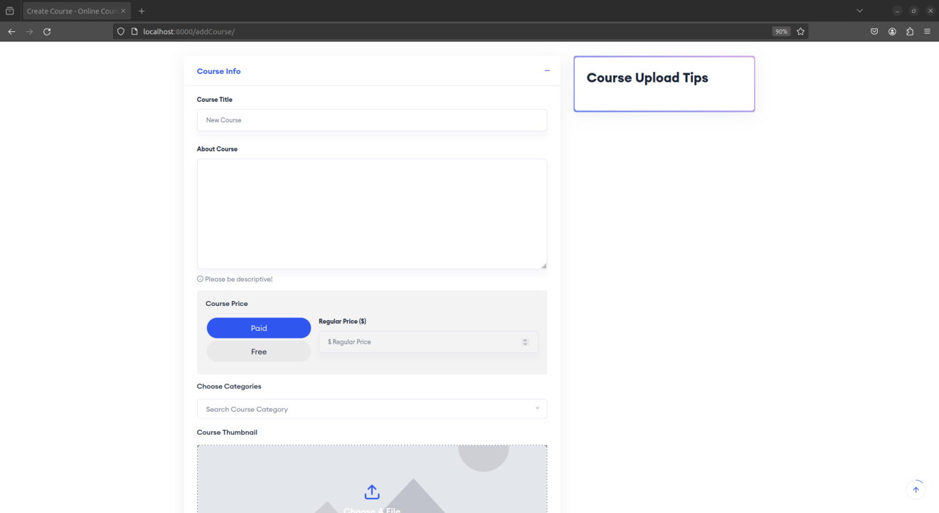

Figure 29:upload courses interface

After adding a new course, administrators are redirected back to the course management page within the admin panel. Here, they can see the updated list of courses, including the newly added one,

After administrators add a course to the platform, they may find it necessary to either delete the course or make changes to ensure its information remains accurate and relevant. When administrators wish to edit a course, they simply click on the edit button, which redirects them to the edit page. From there, they can update various details.

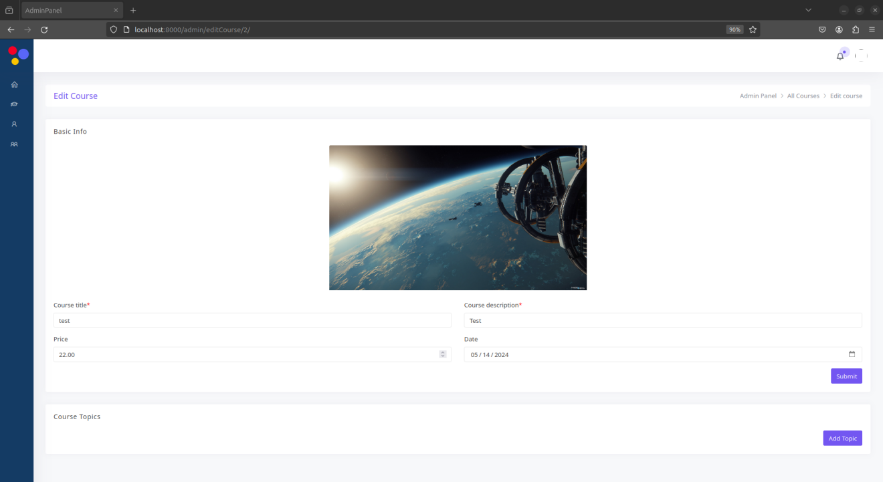

Figure 30:edit course interface

In addition, administrators have the flexibility to modify content modules within the course. They can add new modules

and, within each module, add components such as articles or videos. These modules serve as structured units of content delivery within the course, allowing administrators to organize and present course materials effectively. By actively managing these modules and their contents, administrators ensure that the course content remains up-to-date and aligned with the platform's objectives and user needs.

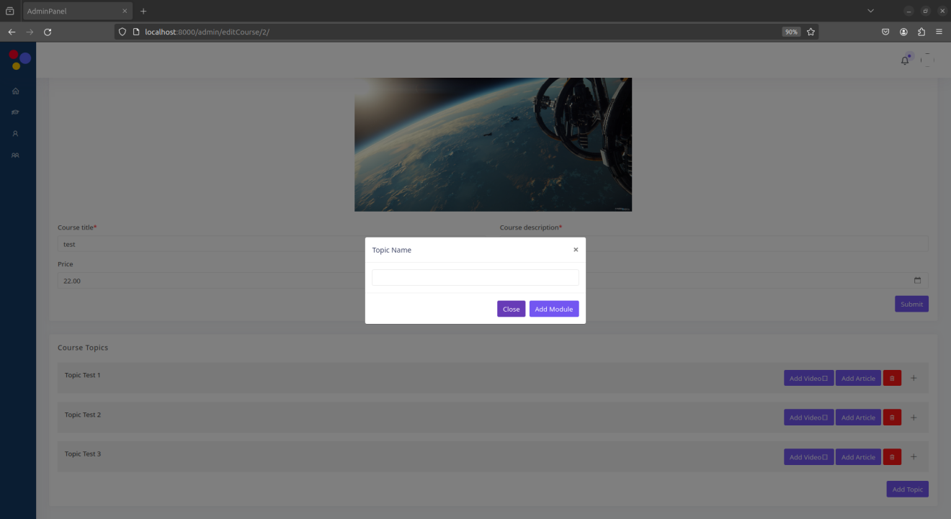

Figure 31:pop up for add a new topic

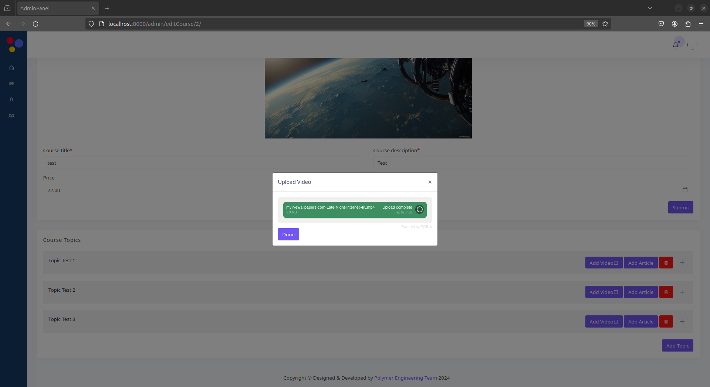

Figure 32:upload videos popup

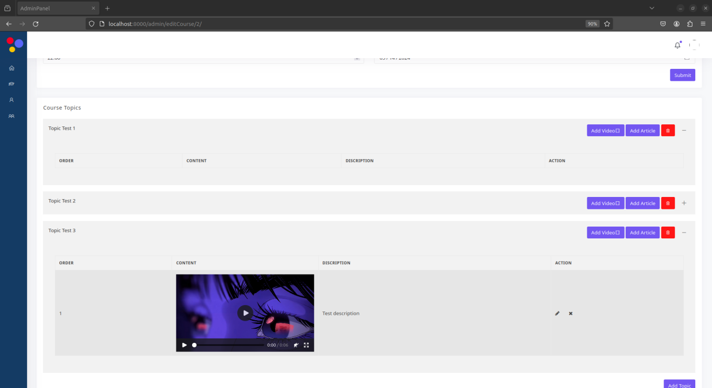

Figure 33:edit course interface after adding a video

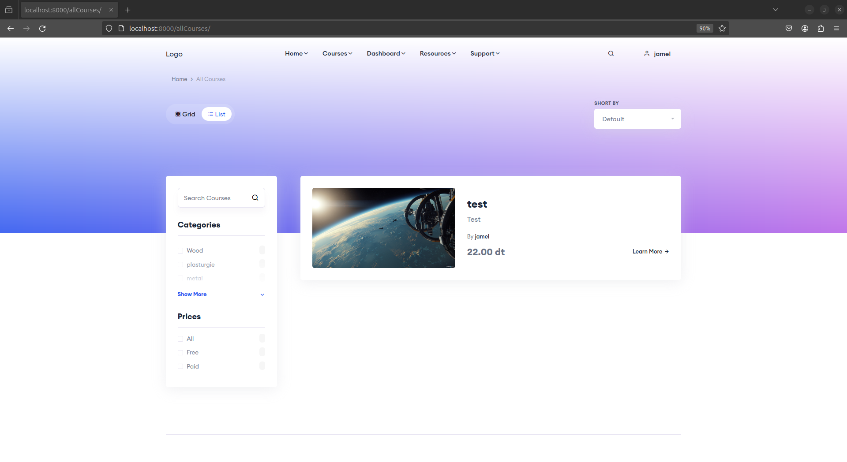

Figure 34: All courses interface for the users

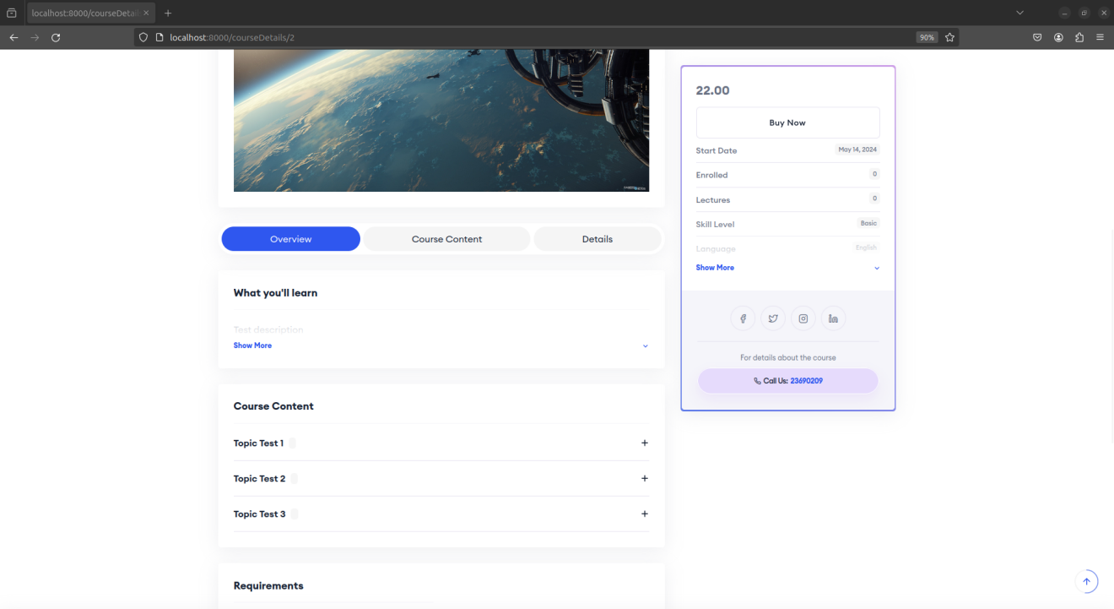

Figure 35:course details interface

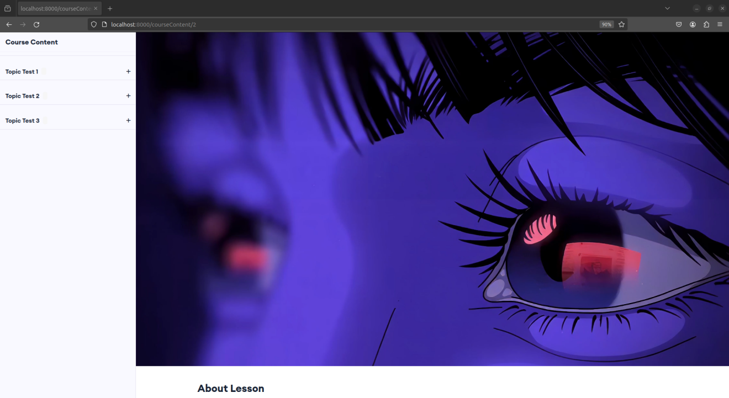

Figure 36:course content interface

### Conclusion

General Conclusion